**Objective: Bridge Design - Automatic Design of Reinforced Concrete Girders with Reinforcements**

**1.Background**

Concrete beams are not only used in bridges and houses, but also in our daily life. For example, benches and chairs in parks and rest halls can be made of concrete, and with the maturity of 3D printing technology and the research and development of new concrete materials, it is possible to make concrete materials into a variety of shapes and forms. There is a Poly bridge in the game world, which is used to simulate the building of bridges, in which various materials are provided, and the player needs to choose the appropriate materials to meet the load-bearing needs of the bridge under a certain budget.

In the case of bridges and houses, the designers need to consider whether the concrete beams will crack under various loads and whether there is a risk of insufficient load-bearing capacity; in the case of concrete chairs and benches, the designers need to consider the problems of cracking and large deformation; in the game, it is hoped that the optimal material, cross-section, and other parameters can be selected to improve the bridge's strength, stiffness, and stability.

How to reduce the cracking of concrete beams, improve the load carrying capacity, one of the most central question is how to allocate reinforcement. So let's experience the design process together, how to realize a better reinforcement for reinforced concrete beams.

|  |  |
| --- | --- |
|  |  |
| 1. Concrete chaise longue | 1. 3D printed concrete outdoor products |
| Figure 1 Concrete supplies | |
|  | |
| 1. “Poly bridge game”Build Bridges | |
|  | |
| 1. collapsed | |
| 图2 Poly bridge game | |
|  | |
| Figure 3 Concrete crack development | |
|  | |
| Figure 4 reinforced concrete beams | |

**2. Description of the topic**

**2.1 Introduction of the topic**

Tongji University proposes to build a bridge in SanhaoWu, but teachers and students have different needs, such as exactly how long the bridge should be built, and how many cars it needs to withstand. But engineers hand-calculate a bridge takes a lot of time, let's use intelligent methods to solve the engineer's problem.

First of all, you need to input the bridge span and load of a certain scheme, and formulate a suitable rectangular cross-section based on experience. Secondly, based on the self-weight of the structure, vehicle loads and crowd loads, it is calculated which location is the most unfavorable for stresses, and this is used as a controlling factor for the reinforcement configuration. The final requirement is to optimize the economy under the premise of structural safety, and finally, the schematic diagram and program interface of the bridge design cross section are drawn accordingly.

|  |
| --- |
|  |
| Figure 5 Schematic diagram of the bridge design section |
|  |
| Figure 6 Program interface |
|  |
| Figure 7 Driving animation |

**2.2 Economic constraining factors**

In general real life, if the use of excessive number of rebar if the construction personnel costs to increase, the number of rebar is less (large diameter) is a certain force advantage, in order to meet the project rationalization to increase the cost is as follows:

1) a cubic meter of concrete 600 yuan;

2) a ton of 14mm diameter rebar for 3500 yuan, the diameter of each 1mm higher cost 2.5%, that is, a ton of 16mm for (1 + 5%) * 3500, the density of rebar is 7.85 tons per cubic meter;

3)Workers need to pay 300 RMB for tying one rebar;

4) The final calculation is based on the total cost.

**2.3 Scoring standard**

1) Completion of topic requirements (80 points)

2) Based on the content of the code (meeting specifications, logic, rigor) (least amount of usage with safety in mind) (is it aesthetically pleasing) (10 points)

3) Complete visual animations or use machine/deep learning to optimize the design process (10 points)

**2.4 Remarks**

Why the car is in the center of the bridge and the force on both sides of the picture is 0%, what is the calculation logic behind the animation?

In real life, the internal forces in a structure due to external load P can be categorized into tension, pressure, shear, bending moment and torque. For bridge structures with very long spans, bending moment and shear force are generally dominant. (Bending moment is actually a moment, which can be composed of a pair of force systems, and can be decomposed into tension and pressure. For Fig. 3 usually the lower edge of the section is subjected to tension, and the upper edge is subjected to pressure, so it is necessary to arrange reinforcement bars on the side subjected to tension to limit the development of cracks.)

As in the calculation of bending moment caused by the load effect, according to the figure below can be seen, in the two kinds of load (uniform and centralized force) under the action of the bending moment of the position of the two sides of the 0. Commonly can be understood as the bend of the more obvious position of the maximum force, that is, the most unfavorable in the span. Students can do an experiment with a straightedge to verify.

On both sides of the main received localized bearing pressure, and subsequently converted into shear force. If a shear check is required, then the pivot points on both sides are unfavorably loaded.

The logic behind the animation calculation is actually digitally driven, in the computer finite element simulation, in order to simplify the real-life problems, in fact, are utilized in the finite unit method, that is, an object is partitioned into a number of small pieces, with each piece of the force on behalf of the overall force, but essentially are mathematical matrix operations, and finally according to the results of the accounted for the drawing of the cloud map, the picture will be linked to each frame is the Animation.

# **Description of parameters**

**3.1 Input Parameters**

1)Reinforced concrete beam span (beam length) L: (10/15/18/20/22/25/28/30m random);

2)Vehicle load size P (100kN,150kN,200kN,250kN,300kN,350kN,400kN randomly);

3)Wheel spacing: 2m≤d≤4m;

Note: Wheel laterals are not considered.

**3.2 Intermediate parameters**

1) Dimensions of beam section: beam width b, beam height h need to be formulated by themselves; (b can be taken in the range of 100~400mm, need to consider how many rows of reinforcement are placed), the relevant information is shown in the appendix - section size reference and section construction.

2) Material grade of steel reinforcement: HRB400 is used; material grade of concrete: C50, relevant information is shown in Appendix-Material Information.

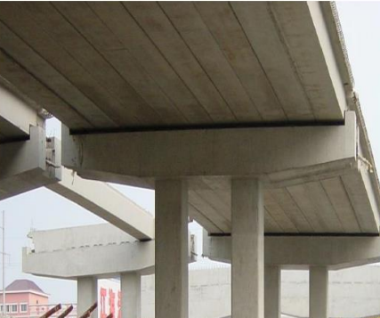

**3.3 Output parameters**

1) Load internal force values of the structure (bending moment and shear force):

2) Limit state calculation of load carrying capacity (bending and shear):

3) Plot the envelope of the section forces, i.e., the external loads Mmax and Qmax versus the flexural and shear capacities for each section.

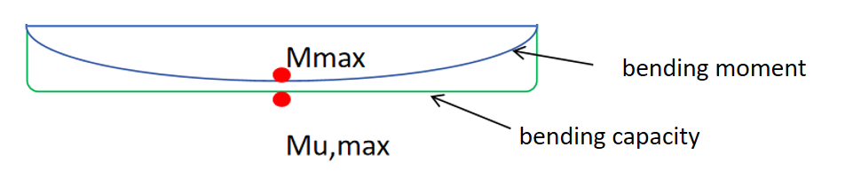

4) Total price: Calculate the quantity spent according to the material.

# **Introduction to the main processes**

**4.1 Calculate the value of the loaded internal force of the structure(bending moment and shear force)**

（1）Formulation of the cross-section

Initially, the width of the cross section b and the height of the cross section h are formulated according to the span l (they can also be obtained by machine learning for advanced tasks).

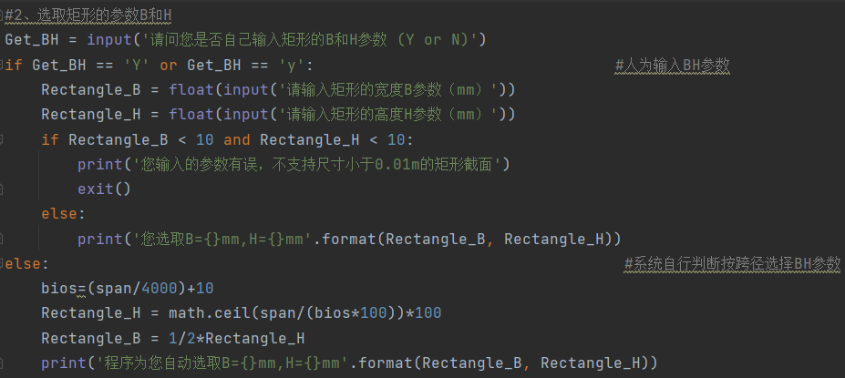

1. Calculation of the most unfavorable cross-section moment for loads

Calculate the internal force MG of the bending moment generated by the self-weight of the bridge (the load is affected by the cross-sectional area) and the bending moment Mp under the vehicle load P (need to determine the most unfavorable when the wheel is in that position), Mmax is the sum of the two, and you need to solve the most unfavorable position, and take this position as a control condition for the check.

Most unfavorable self-weight bending moment：MG = ，Maximum position is mid-span section.

Most unfavorable vehicle bending moment：Mp = ,

Maximum position is the point of load application

Maximum bending moment:Mmax=MG+Mp

**Note:** Multipoint loading can be added linearly, and can be computed by traversing or by writing a function to solve for the extremes.

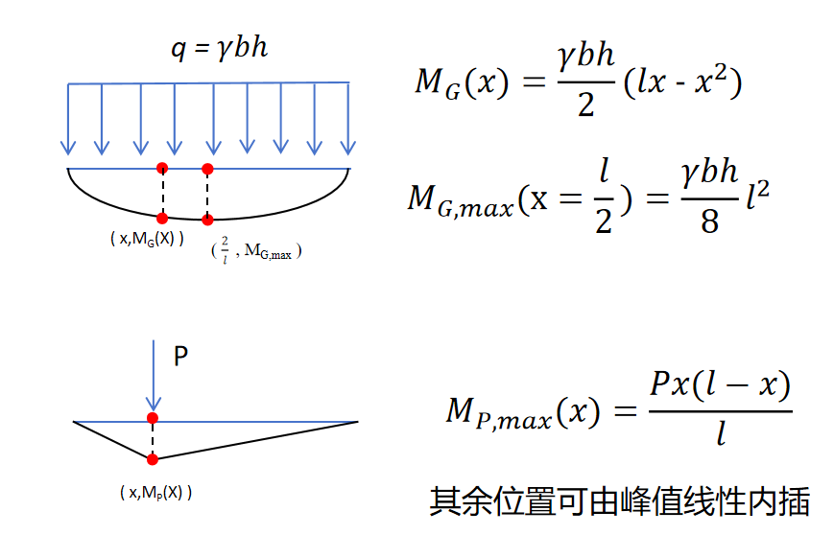

1. Calculate the shear value of the most unfavorable cross-section for the loads

Calculate the shear internal force QG generated by the self-weight of the bridge (the load is affected by the cross-sectional area) and the shear force Qp under the vehicle load P (it is necessary to determine the most unfavorable position of the wheels at that location), both Qmax and Qmin need to be calculated [the plus and minus signs represent the direction], and it is necessary to solve the shear value of each cross-section to find out the most unfavorable position of the load.

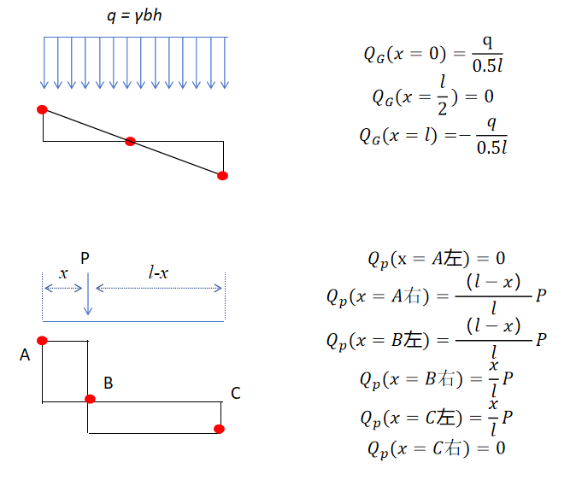

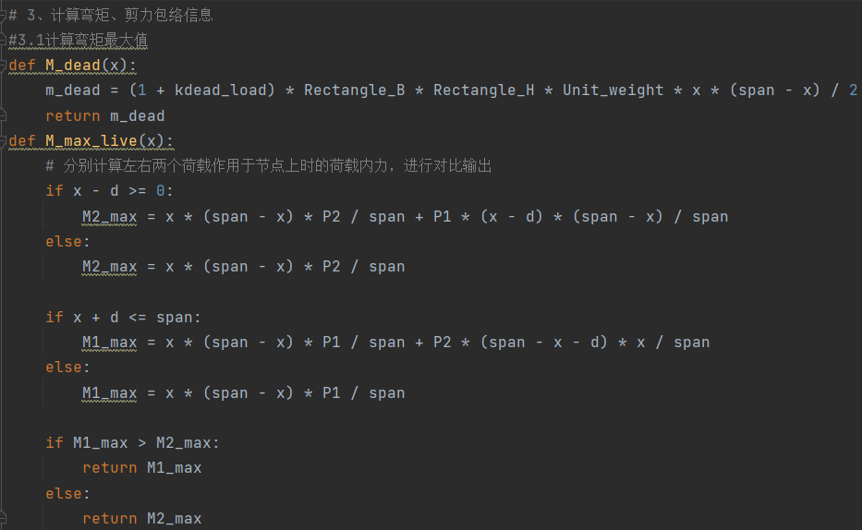

**4.2 Calculation of the structure at the limit state of load carrying capacity**

（1）Calculated flexural load capacity Mu

When ξ＜ξｂ and ρ≥ρmin, the calculation is performed according to Eq.

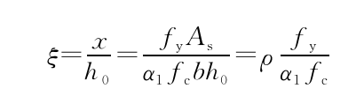

ξｂ=0.518

When the above two conditions are satisfied, the calculation of the maximum bearing capacity Mu

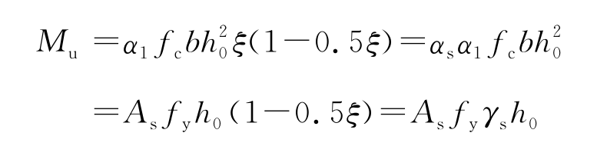

When Mmax＜Mu, i.e., the value of load bending moment is less than the maximum structural capacity Mu, the flexural capacity meets the requirements.

**Note**: ξ is initially provided as a reinforcement area As after the section is selected, which is obtained according to the above formula, where h0 is the distance from the center of gravity location of the reinforcement to the upper surface of the section, as seen in the figure below. ρ is the reinforcement rate of the reinforcement, and ρmin is the minimum reinforcement rate, which must be satisfied for each section. fy is the yield strength of the reinforcement.

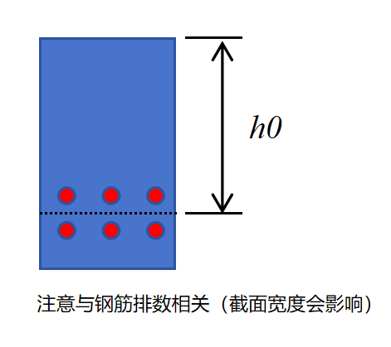

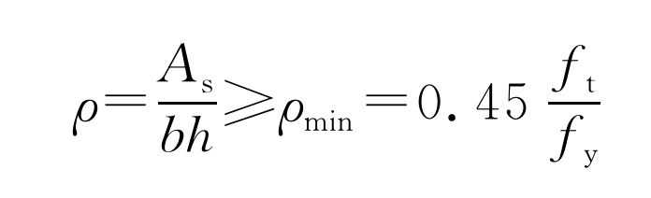

（2）Calculated shear capacity Qu

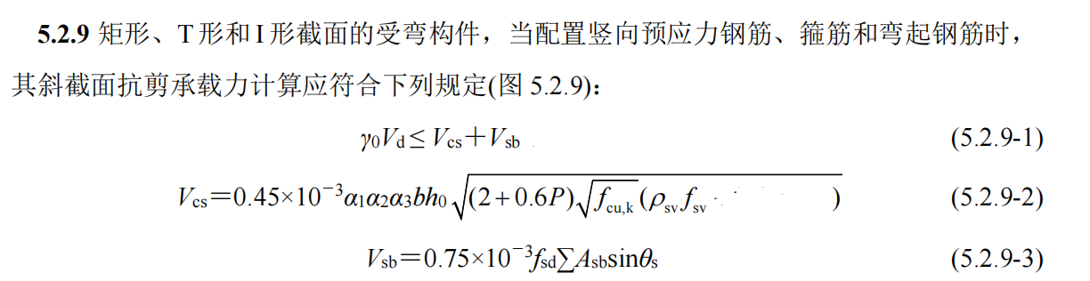

The meaning of the formula is as follows:

γ0 is the safety factor, which can be taken as 1 in this case; a1, a2, and a3 are taken as 1 in this case;Vd is the value of shear force in the most unfavorable section (Qmax and Qmin above), Vcs is the contribution of concrete and hoop reinforcement, and Vsb is the contribution of ordinary bending up reinforcement intersecting the diagonal crack;P is the percentage of reinforcement of longitudinal tension reinforcement within the diagonal section, P = 100ρ, or P = 2.5 when P > 2.5; fcu,k is the compressive strength of concrete (Mpa); ρsv is the hoop ratio (Asv/A total in a diagonal crack), and fsv and fsd take the value of fy, which is the yield strength of the reinforcement. Asb is the area of the reinforcement that intersects the diagonal cross-section. *Θ*s can be taken as 45°.

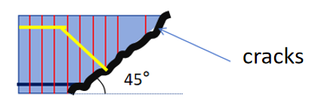

**Appendix**

**1.Cross-section Size Requirements**

The width of the beam b is normally taken as 150, 180, 200, 220 and 250 mm, and is thereafter increased in 50 mm modes (the smallest unit of increment). The height of the beam h is increased in modulus of 50 mm for beams above 200 mm and in modulus of 100 mm for beams above 800 mm.

Rectangular cross-section beam height and beam width ratio h / b initially take 1.5 ~ 3, the section height can be 1 / 10 ~ 1 / 18 of the span.

**2.Reinforcement requirements**

The diameter of longitudinal stress reinforcement in the beam is usually 10-28mm (generally 14-40mm in bridges), the number of longitudinal reinforcement is at least two (when B < 100mm, one can be used), and the clear distance between reinforcement bars is ≥ 25mm or the diameter of reinforcement bars d, that is ma'

x(d, 25).

The thickness of the protective layer of concrete can be taken as 30mm.

Reinforcement rate: General engineering economic reinforcement rate of 0.6% to 1.5% .

Minimum reinforcement rate:

Maximum reinforcement rate: controlled by the height of the compression zone, ξ < ξb = 0.518

**3.Material parameters**

|  |  |  |
| --- | --- | --- |
|  | compressive strength | tensile  strength |
| C50 concrete | fc 32.4Mpa | ft 2.65Mpa |
| Reinforcing steel HRB400 | - | fy 400Mpa |

Unit system: Recommended units are N,mm,Mpa, and the outline of the internal force of bending moment is N*mm.

1Mpa=1N/(mm^2)=1e6Pa